**7.5 Trigonometric Ratios**

1.

a) Find the sin *A*, cos *A*, and tan *A* for the triangle below.

*C* 8 *A* sin *A* =

15 17 cos *A* =

tan *A* =

*B*

b) Find the sin *B*, cos *B*, and tan *B* for the triangle above.

sin *B* = cos *B* = tan *B =*

c) Use the Pythagorean Theorem to show that the triangle above is a right triangle.

d) What is the relationship between sin *A* and cos *B*? Why is that the case? Explain in 2 complete sentences.

2. Solve for x. Then find the trigonometric ratios for each acute angle in the right triangle.

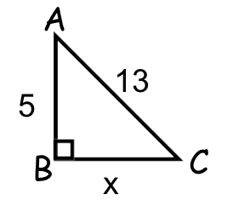

x =

sin *A* = cos *A* = tan *A =*

sin *C* = cos *C* = tan *C =*

3. Solve for x. Then find the trigonometric ratios for each acute angle in the right triangle.

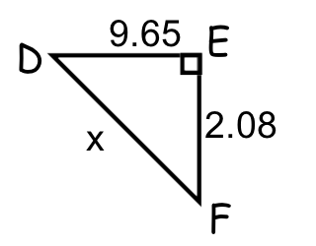x =

sin *D* = cos *D* = tan *D =*

sin *F* = cos *F* = tan *F =*

4. Solve for MK and solve for x using the Pythagorean Theorem. Then find the trigonometric ratios for each acute angle in the right triangle.

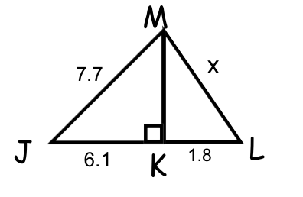

MK = x =

sin *J* = cos *J* = tan *J =*

sin *L* = cos *L* = tan *L =*

sin $∠$*JMK* = cos $∠$*JMK* = tan $∠$*JMK =*

sin $∠$*LMK* = cos $∠$*LMK* = tan *LMK =*

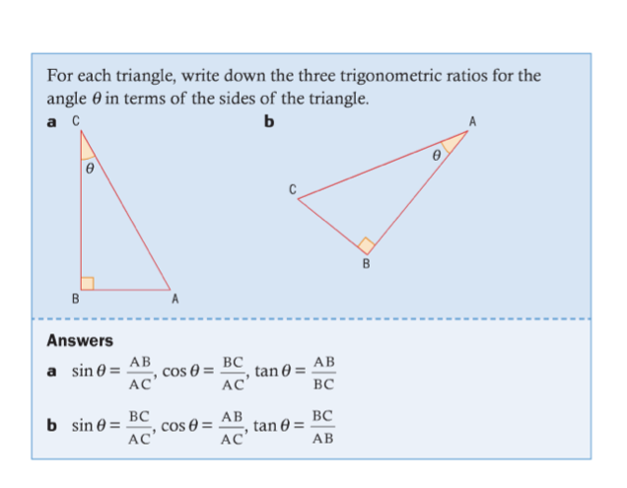  
5. ***IB style question!***

a.

sin $θ$ =

cos $θ$ =

tan $θ$ =

b.

sin $θ$ =

cos $θ$ =

tan $θ$ =

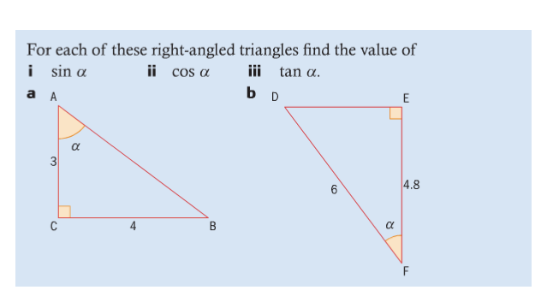6. ***IB style question!*** *Hint: Use the Pythagorean Theorem first!*

a.

sin $α$ =

cos $α$ =

tan $α$ =

b.

sin $α$ =

cos $α$ =

tan $α$ =

**7.5 Exit Slip**

**1) Find the sin *X*, cos *X*, and tan *X* for the triangle below.**

***Z*** 24 ***X***

sin *X* =

7 25

cos *X* =

***Y*** tan *X =*

**2) Find the sin *Y*, cos *Y*, and tan *Y* for the triangle above.**

sin *Y* = cos *Y* = tan *Y =*

**3) Use the Pythagorean Theorem to show that the triangle above is a right triangle.**

**4) What is the relationship between sin *X* and cos *Y*? Why does this relationship exist?**